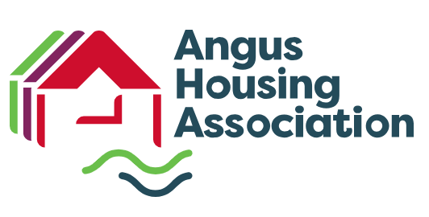

**JOB PROFILE**

|  |  |  |  |
| --- | --- | --- | --- |
| **POST** | Trainee Governance Officer | **DEPARTMENT** | Corporate Services |
| **RESPONSIBLE TO** | Chief Executive Officer | **SCALE** | Starting Grade 3 (£33,887-£37,653)  Qualified Grade 4 (£39,536-£43,927) |
| 1. **JOB PURPOSE** | | | |
| * To support the Association’s Board of Management and Senior Management Team to ensure the Association meets its statutory and regulatory compliance obligations * Assist the SMT to evidence the delivery of excellent performance by identifying areas for improvement or change | | | |
| 1. **KEY RESPONSIIBILITIES** | | | |
| * Mange the Association’s Governance Calendar with inputs to key submissions, overseeing maintenance of the Policy Register and policy requirements * Assist the SMT to ensure the Association maintains full compliance with Regulatory Standards of governance, financial management, data protection, FOI and Equal Opportunities * Work with other departments to ensure that the Association provides full compliance in relation to tenant health and safety obligations * Provide advice on compliance for policy development and review * Participate in Internal Audit planning and management * Assist the Board of Management to ensure decision making is underpinned by robust, compliant and transparent governance principles * Oversee the completion and submission of key submissions, working with the Association’s Business Support Analyst, with a particular focus on the ARC and the Annual Assurance Statement, ensuring evidence-based practice * Ensure the tasks required of the Company Secretary, as set out in the Association’s Rules are appropriately discharged * Monitor performance and compliance with the Association’s Complaints Handling Policy and where required, participate in the investigation of Stage 2 complaints | | | |
| 1. **QUALITIES/COMPETENCIES** | | | |
| * Commitment to demonstrating the Association’s values of Respect, Putting the Customer First, Social Values and Embracing Adaptability/Innovation in all areas of service delivery * Display good judgement, patience and problem-solving abilities * Excellent organisational skills, evidencing the ability to self-manage time and resources * Display a high level of integrity and confidentiality * Ability to work to and deliver on strict deadlines, providing detailed analysis with complex data * Well-developed communication skills including verbal and written skills, negotiation and influencing * Awareness of current issues affecting the Associations and the wider housing and social sectors, demonstrating ability to interpret government and Local Authority strategies and investigate relevance to AHA * Capacity to build professional relationships * Demonstrate commitment to continuous improvement | | | |
| 1. **QUALIFICATIONS/EXPERIENCE** | | | |
| **Essential:**   * Educated to HNC level   **Desirable:**   * Recognised qualification in Governance * Chartered Institute of Housing (CIH) membership * Experience of working in charity/third sector * Good understanding of SHR’s regulatory framework | | | |
| 1. **Other Information** | | | |
| This is a trainee post. The salary starts at Grade 3 until the Corporate Governance Qualifications (at either degree or diploma level) are gained at which time the post will be paid at Grade 4. | | | |