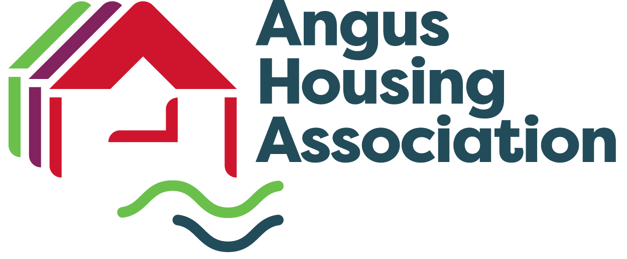

Angus Housing Association
Complaints Handling Procedure

Contents
What is a complaint? 3
What can I complain about? 3
What can’t I complain about? 4
Who can complain? 4
How do I complain? 5
Our contact details 5
How long do I have to make a complaint? 6
What happens when I have complained? 6
Stage 1: Frontline response 6
Stage 2: Investigation 6
What if I’m still dissatisfied? 7
Care complaints 8
Reporting a significant performance failure to the Scottish Housing Regulator 8
Getting help to make your complaint 9
Our contact details 9

Angus Housing Association is committed to providing high-quality customer services.
We value complaints and use information from them to help us improve our services.
- If something goes wrong or you are dissatisfied with our services, please tell us. This leaflet describes our complaints procedure and how to make a complaint. It also tells you about how we will handle your complaint and what you can expect from us.

What is a complaint?
- We regard a complaint as any expression of dissatisfaction about our action or lack of action, or about the standard of service provided by us or on our behalf.

What can I complain about?
- You can complain about things like:
- failure or refusal to provide a service
- inadequate quality or standard of service, or an unreasonable delay in providing a service
- delays in responding to enquiries or requests
- unfairness, bias or prejudice in service delivery
- lack of provision, or the provision of misleading, unsuitable or incorrect advice or information
- a repair that has not been carried out properly or in an agreed timeframe
- dissatisfaction with one of our policies or its impact on the individual
- failure to properly apply law, procedure or guidance when delivering services
- failure to follow the appropriate administrative process
- conduct, treatment by or attitude of a member of staff or contractor (except where there are arrangements in place for the contractor to handle the complaint themselves); or
- disagreement with a decision, (except where there is a statutory procedure for challenging that decision, or an established appeals process followed throughout the sector).
- Your complaint may involve more than one [organisation] service or be about someone working on our behalf.

What can’t I complain about?
- There are some things we can’t deal with through our complaints handling procedure. These include:
- a routine first-time request for a service
- a request for compensation only
- issues that are in court or have already been heard by a court or a tribunal (if you decide to take legal action, you should let us know as the complaint cannot then be considered under this process)
- disagreement with a decision where there is a statutory procedure for challenging that decision (such as for freedom of information and subject access requests), or an established appeals process followed throughout the sector
- a request for information under the Data Protection or Freedom of Information (Scotland) Acts
- a grievance by a staff member or a grievance relating to employment or staff recruitment
- a concern raised internally by a member of staff (which was not about a service they received, such as a whistleblowing concern)
- a concern about a child or an adult’s safety
- an attempt to reopen a previously concluded complaint or to have a complaint reconsidered where we have already given our final decision
- abuse or unsubstantiated allegations about our organisation or staff where such actions would be covered by our [Unacceptable Actions Policy or equivalent]; or
- a concern about the actions or service of a different organisation, where we have no involvement in the issue (except where the other organisation is delivering services on our behalf).
- If other procedures or rights of appeal can help you resolve your concerns, we will give information and advice to help you.

Who can complain?
- Anyone who receives, requests or is directly affected by our services can make a complaint to us. This includes the representative of someone who is dissatisfied with our service (for example, a relative, friend, advocate or adviser). If you are making a complaint on someone else’s behalf, you will normally need their written consent. Please also read the section on Getting help to make your complaint below. Third Party Consent forms are available on request.

How do I complain?
- You can complain in person at any of Angus Housing Association Offices, by phone, in writing, by email or via our complaints form https://www.angusha.org.uk/contact.html
- It is easier for us to address complaints if you make them quickly and directly to the service concerned. So please talk to a member of our staff at the service you are complaining about. Then they can try to resolve the issue.
- When complaining, please tell us:
- your full name and contact details
- as much as you can about the complaint
- what has gone wrong; and
- what outcome you are seeking.

Our contact details

Angus Housing Association Limited:- Arbroath Office, 93 High Street
Arbroath,Angus DD11 1DP. Dundee Office,The Square,Ormiston Crescent
Dundee, DD4 0UD. Telephone:- 03451 772244, Email:- admin@aha.org.uk, Website:- www.angusha.org.uk

Opening Times
Monday – 10am to 4pm *
Tuesday – 10am to 4pm *
Wednesday – 12 noon to 4pm *
Thursday – 10am to 4pm *
Friday – 10am to 4pm
* Monday to Thursday
phone calls are answered to 5.00pm

How long do I have to make a complaint?
- Normally, you must make your complaint within six months of:
- the event you want to complain about; or
- finding out that you have a reason to complain.
- In exceptional circumstances, we may be able to accept a complaint after the time limit. If you feel that the time limit should not apply to your complaint, please tell us why.

What happens when I have complained?
- We will always tell you who is dealing with your complaint. Our complaints procedure has two stages.

Stage 1: Frontline response
- We aim to respond to complaints quickly (where possible, when you first tell us about the issue). This could mean an on-the-spot apology and explanation if something has clearly gone wrong, or immediate action to resolve the problem.
- We will give you our decision at stage 1 in five working days or less, unless there are exceptional circumstances.
- If you are not satisfied with the response we give at this stage, we will tell you what you can do next. If you choose to, you can take your complaint to stage 2. You must normally ask us to consider your complaint at stage 2 either:
- within six months of the event you want to complain about or finding out that you have a reason to complain; or
- within two months of receiving your stage 1 response (if this is later).
- In exceptional circumstances, we may be able to accept a stage 2 complaint after the time limit. If you feel that the time limit should not apply to your complaint, please tell us why.

Stage 2: Investigation
- Stage 2 deals with two types of complaint: where the customer remains dissatisfied after stage 1 and those that clearly require investigation, and so are handled directly at this stage. If you do not wish your complaint to be handled at stage 1, you can ask us to handle it at stage 2 instead.
- When using stage 2:
- we will acknowledge receipt of your complaint within three working days
- we will confirm our understanding of the complaint we will investigate and what outcome you are looking for
- we will try to resolve your complaint where we can (in some cases we may suggest using an alternative complaint resolution approach, such as mediation); and
- where we cannot resolve your complaint, we will give you a full response as soon as possible, normally within 20 working days.
- If our investigation will take longer than 20 working days, we will tell you. We will tell you our revised time limits and keep you updated on progress.

What if I’m still dissatisfied?
- After we have given you our final decision, if you are still dissatisfied with our decision or the way we dealt with your complaint, you can ask the Scottish Public Services Ombudsman (SPSO) to look at it.
The SPSO are an independent organisation that investigates complaints. They are not an advocacy or support service (but there are other organisations who can help you with advocacy or support).
You can ask the SPSO to look at your complaint if:
- you have gone all the way through the [organisation]'s complaints handling procedure
- it is less than 12 months after you became aware of the matter you want to complain about; and
- the matter has not been (and is not being) considered in court.

The SPSO will ask you to complete a complaint form and provide a copy of our final response to your complaint. You can do this online at www.spso.org.uk/complain/form or call them on Freephone 0800 377 7330.
You may wish to get independent support or advocacy to help you progress your complaint. See the section on Getting help to make your complaint below.
The SPSO’s contact details are:
SPSO
Bridgeside House
99 McDonald Road
Edinburgh
EH7 4NS
(if you would like to visit in person, you must make an appointment first)

Their freepost address is:
FREEPOST SPSO

Freephone: 0800 377 7330
Online contact www.spso.org.uk/contact-us
Website: www.spso.org.uk

- There are some complaints about housing that have an alternative route for independent review. We will tell you how to seek independent review when we give you our final response on your complaint.

Care complaints
- If your complaint relates to a care service we provide, you can choose whether to complain to us or the Care Inspectorate. You can find out more about their complaints procedure, or make a complaint, by contacting them.
The Care Inspectorate has several offices around Scotland. Please refer to: http://www.scswis.com/

Factoring complaints
- The SPSO does not normally look at complaints about our factoring service. The Homeowners Housing Panel was set up in October 2012 to deal with complaints and disputes between home owners and property factors. From 1st December 2016 this became the First-Tier Tribunal for Scotland Housing and Property Chamber so if you have a complaint about a factoring service, and you are still dissatisfied after our investigation stage you will be able to go to the First-Tier Tribunal for Scotland and Property Chamber.

The Housing and Property Chamber can be contacted as follows:

Housing and Property Chamber
First-Tier Tribunal for Scotland
Glasgow Tribunals Centre
20 York Street
Glasgow
G2 8GT

Telephone: 0141 302 5900
Email: HPCadmin@scotcourtstribunals.gov.uk
Website: www.housingandpropertychamber.scot

Reporting a significant performance failure to the Scottish Housing Regulator
- The Scottish Housing Regulator (SHR) can consider issues raised with them about ‘significant performance failures’. A significant performance failure is defined by the SHR as something that a landlord does or fails to do that puts the interests of its tenants at risk, and which the landlord has not resolved. This is something that is a systemic problem that does, or could, affect all of a landlord’s tenants. If you are affected by a problem like this, you should first report it to us. If you have told us about it but we have not resolved it, you can report it directly to the SHR.
- A complaint between an individual tenant and a landlord is not a significant performance failure. Significant performance failures are not, therefore, dealt with through this complaints handling procedure. You can ask us for more information about significant performance failures. The SHR also has more information on their website: www.scottishhousingregulator.gov.uk/

Getting help to make your complaint
- We understand that you may be unable or reluctant to make a complaint yourself. We accept complaints from the representative of a person who is dissatisfied with our service. We can take complaints from a friend, relative, or an advocate, if you have given them your consent to complain for you.
- You can find out about advocates in your area by contacting the Scottish Independent Advocacy Alliance:
Scottish Independent Advocacy Alliance
Tel: 0131 510 9410 Website: www.siaa.org.uk

- You can find out about advisers in your area through Citizens Advice Scotland:
Citizens Advice Scotland
Website: www.cas.org.uk or check your phone book for your local citizens advice bureau.

www.happytotranslate.com for customers who speak little or no English.
- We are committed to making our service easy to use for all members of the community. In line with our statutory equalities duties, we will always ensure that reasonable adjustments are made to help you access and use our services. If you have trouble putting your complaint in writing, or want this information in another language or format, such as large font, or Braille, please tell us in person, contact us on 03451 772244, email us at admin@aha.org.uk.

Our contact details
- Please contact us by the following means:

In writing or person at Angus Housing Association Limited:- Arbroath Office, 93 High Street,Arbroath,Angus DD11 1DP. Dundee Office,The Square,Ormiston Crescent,Dundee, DD4 0UD. By Telephone:- 03451 772244, By Email:- admin@aha.org.uk, Via Website:- www.angusha.org.uk https://www.angusha.org.uk/contact.html
We can also give you this leaflet in other languages and formats (such as large print, audio and Braille).

Quick guide to our complaints procedure
Complaints procedure
You can make your complaint in person, by phone, by email or in writing.

We have a two-stage complaints procedure. We will always try to deal with your complaint quickly. But if it is clear that the matter will need investigation, we will tell you and keep you updated on our progress.

If your complaint relates to a care service you can choose to complain to us or to the Care Inspectorate.
Stage 1: Frontline response

We will always try to resolve your complaint quickly, within five working days if we can.

If you are dissatisfied with our response, you can ask us to consider your complaint at stage 2.
Stage 2: Investigation

We will look at your complaint at this stage if you are dissatisfied with our response at stage 1. We also look at some complaints immediately at this stage, if it is clear that they need investigation.

We will acknowledge your complaint within three working days.

We will confirm the points of complaint to be investigated and what you want to achieve.

We will investigate the complaint and give you our decision as soon as possible. This will be after no more than 20 working days unless there is clearly a good reason for needing more time.
Scottish Public Services Ombudsman

If, after receiving our final decision on your complaint, you remain dissatisfied with our decision or the way we have handled your complaint, you can ask the SPSO to consider it.
There are some complaints about housing that have an alternative route for independent review. We will tell you how to seek independent review when we give you our final response on your complaint.

