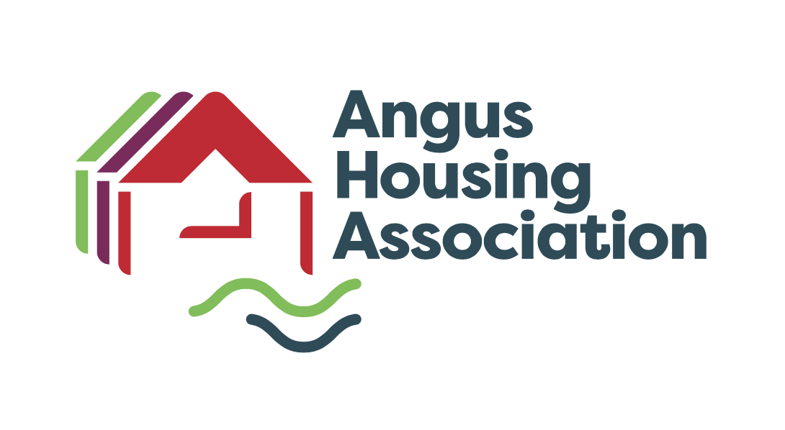

|  |  |  |  |
| --- | --- | --- | --- |
| **Policy Name** | | Abandonment Policy | |
| **Policy Ref** | |  | |
| **Review Date** | | February 2023 | |
| **Purpose** | | REVIEW & APPROVE | |
| **Next Review Date** | | February 2028 | |
| **Committee** | | Service Delivery Policy | |
| **Author** | | Linlay Anderson | |
| **Internal Policy** |  | **To be published** |  |

Angus Housing Association Registered Charity Number SC020981

|  |  |
| --- | --- |
| **Scottish Social Housing Charter**  **Outcomes** | Number(s) |
| **The Customer/landlord relationship** | 1.Equalities  2.Communication  3.Participation  4.Quality of Housing  5.Repairs, Maintenance and Improvements  6. Estate Management, Anti-Social Behaviour, Neighbour Nuisance and Tenancy Disputes  7,8 & 9 Housing Options  11. Tenancy Sustainment |

|  |  |
| --- | --- |
| **Written By** | Linlay Anderson |
| **Department** | Housing Management |

|  |  |
| --- | --- |
| **Approval Date by Committee** | 8th February 2023 |

|  |  |
| --- | --- |
| **Notes** |  |
| We will comply with all relevant legislation and associated regulations, including:  The Housing (Scotland) Act 1987, 2001  The Homelessness etc (Scotland) Act 2003  Data Protection Act (1998 and 2018)  Reference made to the following sources and other guidance: | |

**ANGUS HOUSING ASSOCIATION LIMITED**

**ABANDONED TENANCIES POLICY**

1. **Introduction**

This policy is compiled in accordance with the procedures outlined in the Housing (Scotland) Act 2001, particularly Section 17 -21 and the Scottish Secure Tenancies (Abandoned Property) Order 2002.

Sole Tenancy or Joint Tenancy

Where the Association has reasonable grounds for believing that the house is empty and that the tenant does not intend to occupy it as her/his only or principal home. Housing (Scotland) Act 2001 Section 17 & 19.

Joint Tenancy

Where the Association has reasonable grounds for believing that a joint tenant is not occupying the house and does not intend to occupy it as her/his only principal home. Housing (Scotland) Act 2001 Section 20 & 21.

1. **Policy**

The Association will endeavour to identify abandoned properties at the earliest possible stage in order to minimise rent loss resulting from abandoned Tenancies and to follow the Guidance as detailed in the Scottish Secure Tenancy (Abandoned Property) Order 2002.

However a property will not be treated as abandoned until the Association is satisfied that all appropriate checks have been carried out.

In the event that attempts to contact the tenant reveal that the tenant has died, reference should be made to the Succession Policy and Procedures.

The Housing Act 2001 and the SST Agreement gives Angus Housing Association the right to enter houses which are unoccupied and where there are reasonable grounds to believe that it is abandoned, to secure against vandalism weather or frost damage. If emergency forced entry is required, the police will be invited to attend. Details of where new keys can be obtained will be attached to the door of the property and provided to the Local Authority’s out of hours homelessness service. If the property is not considered to be at risk, no forced entry will be made at this time.

Detailed procedures have been drafted to supplement this policy.

**2. Establishing whether the house has been abandoned**

Housing officers will follow detailed procedures to establish that the tenancy is unoccupied and has been abandoned. Staff will also follow the guidance in the Association’s Health and Safety manual.

A detailed checklist will assist Housing Officers in following the procedures. Staff will act proactively in order to avoid lengthy delays when trying to establish contact with relatives, neighbours etc.

**3. Abandonment**

Where it is established that a house has been abandoned, the Housing Officer will serve a statutory Notice of Intention to Repossess the Dwellinghouse, giving a minimum of 28 days notice. The Housing Officer and one other member of staff will deliver the Notice which will be signed and dated, the Association will also retain a signed and dated copy of the Notice.

Should the tenant fail to contact the office following delivery of the Abandonment Notice and before the Abandonment Notice expires, a second Abandonment Notice of Repossession will be served. The second Abandonment Notice will be served on or after the date the first Abandonment Notice expires. The second Abandonment Notice effectively ends the tenancy.

**4. Locks/Inspection/Furniture**

Thereafter the locks of the house will be changed and the house will be inspected for any remaining furniture. If furniture is found photographs should be taken to show the condition of items, and a further Notice with inventory will be served on the former tenant at the last known address (i.e. the abandoned property). This allows a minimum of 28 days for the former tenant to arrange delivery/pick up the furniture. This Notice may also be served earlier if it is known that furniture has been left in the house.

The Association will charge any expenses incurred in complying with such a request and will release any furniture only on payment of such sum.

1. **Storage of property**

Where property has not been collected by the former tenant, Angus Housing Association will store the furniture for a period of 6 months from the date on which the association took possession of the house.

Property, which in the opinion of the Housing officer is of insufficient value to cover the costs of transport and storage will be removed after the period of 28 days previously mentioned in paragraph 4 above. The Housing Officer will detail an inventory along with photographs for record purposes.

After 6 months, unclaimed property will be sold to meet expenses such as transport of the property, storage costs, and then any rent arrears, recoverable repairs etc.

Nothing in our policy shall affect Angus Housing Associations right of hypothec.

(Hypothec is a common law right over all moveable property in a house, with certain exceptions - such as bedding, chairs, tables, cooking utensils, clothes and tools of trade when there is rent due).

The landlord can hold this property until the rent due is paid. The Housing Manager will consult with our solicitor before exercising such rights.

**6. Joint Tenants**

The Housing (Scotland) Act 2001 introduced new legislation concerning joint tenancies where one partner had abandoned their tenancy.

If Angus Housing Association has reasonable grounds to believe that a joint tenant has abandoned their tenancy, that tenant will be given notification in writing that their interest in the property will be terminated within twenty-eight days. If there is no response from the member at the end of the twenty-eight days notice and the association has reasonable grounds for believing that the member has abandoned the property, a second notice will be served which will terminate that joint tenants ***interest*** in the tenancy after a further twenty-eight days.

Therefore the joint tenant’s ***interest*** in the property will end fifty-six days following the serving of the first notice. It should be noted that the second notice does not terminate the tenancy, which will continue in the remaining joint tenant’s name. A joint tenant who has abandoned their interest in the property has eight weeks to appeal against the decision.

If the joint tenant who abandoned leaves personal belongings in the property, and the remaining member does not want them, the association has no legal obligation to remove these belongings from the property. However, discretion can be exercised. Copies of the notices will also be served on the other joint tenant(s)

1. **Court Action**

Tenants have 6 months from the date of repossession in which to complain to the Courts. If the Court holds that Angus Housing Association failed to comply with the statutory procedures, or did not have reasonable grounds for finding that the house was abandoned, the Court may instruct the tenancy to continue (if the house has not been relet) or, alternatively, will ensure the association makes suitable alternative accommodation available to the tenant.

1. **Equal Opportunities**

In developing and implementing policies covering all aspects of our work, Angus Housing Association will ensure that our strong principles and commitment to equality of opportunity are evident. In line with the Housing (Scotland) Act 2001 the Association operates in a manner which encourages equal opportunities and observes the equal opportunity requirements described in Section 106 of the Act. The Association also takes account of all applicable legislation, including the Equality Act 2010 and relevant Codes of Practice issued by the Equality and Human Rights Commission -

Our Policy recognises the protected characteristics as defined by the Equalities Act

|  |  |
| --- | --- |
| * Age * Disability * Gender reassignment * Marriage and civil partnership * Pregnancy and maternity | * Race * Religion or belief * Gender * Sexual orientation |

In line with this commitment to equal opportunities, this policy and any summary or information leaflet can be made available free of charge in a variety of formats including large print, translated into another language or on audio tape.

1. **Register of Abandoned Houses**

A register must be kept of all abandoned tenancies and where property has been found this must be recorded. A house will remain on the register for five years from the date of repossession and the register should be open for public inspection.

**10. Monitoring and Reporting**

It will be the responsibility of the Director of Housing Services to provide a quarterly report to the Service Delivery Sub Committee on the

* Number of abandonments completed

Annually the Director of Housing Services will provide a report on the following key information –

* Number of abandonment procedures commenced
* Number of abandonment procedures completed
* Number of abandonment procedures cancelled

**11. Review**

The targets for monitoring the progress of abandoned properties will be reviewed annually, taking into account any legislative or other changes.

When reviewing the management of abandoned properties, the following information will be used to improve service delivery by –

* Monitoring comments and complaints received
* The number of appeals to be re-housed by former tenant where an abandonment has taken place
* Feedback from the Committee of Management and Service Delivery Sub Committees

Unless recommended through analysis of the abandonment process, feedback from tenants, a change in legislation, the Abandonment Policy will be reviewed every five years.