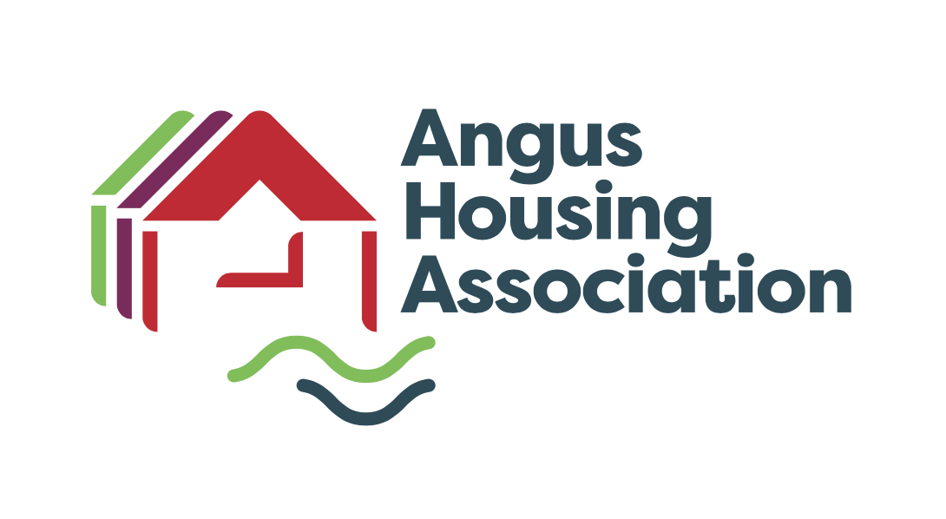

|  |  |  |  |
| --- | --- | --- | --- |
| **Policy Name** | | Customer Care Policy | |
| **Policy Ref** | | HM | |
| **Review Date** | | May 2023 | |
| **Purpose** | | REVIEW & APPROVE | |
| **Next Review Date** | | May 2027 | |
| **Committee** | | Service Delivery Sub Committee | |
| **Author** | | Linlay Anderson & Alison Geoghans | |
| **Internal Policy** |  | **To be published** | X |

|  |  |
| --- | --- |
| **Scottish Social Housing Charter** | **Outcomes** |
| This policy has been developed with reference to The Scottish Social Housing Charter | 1 Equalities, 2 Communication and 11 Tenancy Sustainment |

|  |
| --- |
| Notes:  This policy has been drawn up with reference to:  The Housing (Scotland) Act 2001  The Housing (Scotland) Act 2014  Unacceptable Actions Policy  Access to Information Policy  Complaints Policy  Equalities Policy  Other useful references:  Repairs and Maintenance – Code of Conduct for Contractors  Staff Code of Conduct  Health and Safety Policy  Tenant Handbook  Angus Housing Association Limited Registered Charity Number SC020981 |

**ANGUS HOUSING ASSOCIATION LIMITED**

**CUSTOMER SERVICES POLICY**

**1. Introduction**

* 1. In accordance with the Association’s values –
* Putting Customers First
* Respect
* Demonstrating Social Value
* Embracing Innovation and Adaptability

We are committed to delivering an excellent service to all of our customers.

1.2 This policy sets out our approach to achieving the highest standards of Customer Service and we will use it consistently in the delivery of our services.

1.3 We will produce detailed procedures for staff to follow and ensure that our staff are trained to deliver an excellent service.

1.4 We will aim to achieve the relevant Scottish Social Housing Charter outcomes, particularly outcome 1 which states

*“every tenant and other customer has their individual needs recognised, is treated fairly and with respect and receives fair access to housing and housing services”*

**2. Our Customers**

2.1 Our customers are all of the people we come into contact with during the course of our work and include:

* Tenants
* Sharing Owners
* Owners
* These Homes Applicants
* Members of the public
* Local Authorities
* Contractors and Consultants
* Other organisations that we work with

2.2 Although this policy is mainly aimed at external customers, the standards set will also be applied to dealings between staff within the organisation and Board Members.

**3. General Principles of Customer Care**

3.1 In delivering this policy we will ensure that we adhere to our values and comply with the following general principles at all times:

* We will provide a customer oriented service which seeks to put our customers first and respect their rights, needs and opinions
* Our staff will always give their names when in contact with customers
* We will capture all relevant customer information when contact is made to avoid the need for repetition. We will tell you when you can expect to hear from us again if that is necessary
* Staff will be polite, open, and truthful
* The information we provide will be relevant, accurate in Plain English and available in other languages and formats on request
* We will listen to our customers, find out what they want and try to provide it
* Where we are unable to provide the services required by our customers or we are unable to help, we will explain why and, wherever possible, suggest, direct or refer to other agencies
* Where customers cannot access the office, we will visit them at home
* We will listen to our customers and develop our overall knowledge of customer needs, requirements and expectations to ensure we deliver our services with the highest quality and will strive to continuously improve and shape our services to meet the customers’ needs
* We will maximise the use of technology to help deliver high quality, integrated services

**4. Customer Service Standards**

4.1 We are committed to providing a first class service, effective and cost efficient customer service to all our existing and future customers and have developed a Customer Service Standard Leaflet (Appendix 1).

The leaflet will detail how we will interact with customers in the following settings –

* In our offices
* Written communication
* Telephone Calls
* Website
* Home Visits
* Out target response timescales

The Customer Service Standard Leaflet will be available in our office, on our website and will also be included in the New Tenant Pack.

**5. Customer Feedback**

5.1 We will consult with customers on issues that affect them as detailed in our Tenant Participation Strategy.

5.2 When we consult or ask for feedback we will make sure that:

* We provide all the information customers need to allow them to make an informed response
* We provide reply paid envelopes to customers who are not paper-free
* Customers can respond online if they prefer to
* We use the feedback to improve our services and influence our policies
* We report the results to our customers

**6. Customer Satisfaction**

6.1 We will use a variety of methods to measure customer satisfaction including:

* A full, independent, Tenant Satisfaction Survey every three years
* Repair satisfaction surveys for every repair we arrange
* Post contract satisfaction surveys
* New development feedback surveys
* Post allocation feedback surveys
* Financial Inclusion Service feedback surveys
* Termination of Tenancy surveys
* Periodic surveys on specific services such as stair cleaning

6.2 We will use the information gained from these surveys to improve our services and influence our policies.

6.3 We will report the results of these surveys, and what we are doing as a result, to our customers through our website and Newsletters.

**7. When We Get Things Wrong**

7.1 Although we will always strive to deliver excellent service, we acknowledge that we will sometimes make mistakes and will not always get things right first time.

7.2 We will make it easy for customers to complain, formally or informally, by publicising our Comments and Complaints Policy and making it readily available to anyone who wants to use it. Our website includes various ways for customers to give feedback, such as contact forms, “praise or grumble” and Near Me Online Drop In service, as well as giving on-line access to, and information about, our comments and complaints service.

7.3 When we make mistakes we will apologise, put things right as quickly as possible and use the experience to improve our service in the future.

**8. Complaints Procedure**

Any tenant may submit a complaint, using the Association’s Complaints Policy if they feel that the Association has failed to correctly apply this Customer Care Policy.

**9. Confidentiality and Data Protection**

All communications with our customers will be treated in confidence and personal data about our customers will only be made available on a need to know basis to staff within the Association. Customers must understand that if their communication with the Association involves another customer or staff member of the Association, it may be very difficult to consider their communication (if it is a complaint, for example), without the Association communicating with those other individuals. If the customer asks the Association not to do so, then that will be respected, although it may mean that it is not possible for the Association to take any action in response to the customer’s communication.

We recognise the importance of data protection legislation in protecting the rights of individuals in relation to personal data that we may handle and use about them. We will ensure that our practices in the handling and use of personal data as part of the processes outlined in this Customer Services Policy comply fully with data protection legislation. More information is available from our Data Protection Officer

**10. Risk Management**

10.1 Risk arises from the Association’s Customer Services Policy in a number of respects:

* Incorrect service decisions resulting in aggrieved customers
* Damage to the Association’s reputation through inappropriate service

decisions

* Service complaints and ombudsman’s enquiries
* Failure by contractors to uphold service standards

10.2 The management of these risks is based on appropriate training opportunities

being made available to members of staff to ensure high standards of service are maintained.

10.3 The Association’s policy and procedure are reviewed on a regular basis to

ensure that they continue to meet all legislative and regulatory requirements.

**11. Financial Risk**

There are no specific financial risks identified in the implementation of the Customer Services Policy. However, service complaints and ombudsman’s enquiries could possibly result in financial payments being made by the Association as compensation.

Our Complaints Handling Policy clearly advises that the person concerned can complain about the Association to the Scottish Public Service Ombudsman should they feel their complaint has not been dealt with to their satisfaction by the Association in the first instance.

**12.** **Equal Opportunity**

In developing and implementing policies covering all aspects of our work, Angus Housing Association will ensure that our strong principles and commitment to equality of opportunity are evident. In line with the Housing (Scotland) Act 2001 the Association operates in a manner which encourages equal opportunities and observes the equal opportunity requirements described in Section 106 of the Act. The Association also takes account of all applicable legislation, including the Equality Act 2010 and relevant Codes of Practice issued by the Equality and Human Rights Commission -

Our Policy recognises the protected characteristics as defined by the Equalities Act

|  |  |
| --- | --- |
| * Age * Disability * Gender reassignment * Marriage and civil partnership * Pregnancy and maternity | * Race * Religion or belief * Gender * Sexual orientation |

In line with this commitment to equal opportunities, this policy and any summary or information leaflet can be made available free of charge in a variety of formats including large print, translated into another language or on audio tape.

**14. Monitor and Review**

14.1 In consultation with staff we will set targets for all aspects of Customer Care and these targets will be reviewed annually.

14.2 We will report our performance against these targets to the Service Deliver Sub Committee annually; and on our website.

14.4 The Director of Housing Service will ensure this policy is reviewed by the Board of Management every four years.

Appendix 1

**Angus Housing Association**

**Customer Service Standards**

Angus Housing Association aims to deliver excellent services in a variety of innovative and convenient ways**.**

**Our Aims**

* To deliver a personalised high-quality service to all customers in accordance with the Association’s values –
* Putting Customers First
* Respect
* Demonstrating Social Value
* Embracing Innovation and Adaptability
* To have enquiries resolved at the first point of contact.
* We will make it our goal to exceed the expectations of our customers.
* To effectively monitor and evaluate your satisfaction with the services that you receive.
* To listen to your views and feedback and use this to improve our services.
* To treat you fairly and with respect.
* To ensure equal opportunities of access for all in that we do.
* To ensure our contractors and those who provide services on our behalf sign up to these aims.
* To include Customer Service delivery as a key element in the recruitment and development of staff.

**What we ask from you**

* Treat staff with politeness and respect. Abusive or threatening behaviour/ language is not acceptable.
* Understand that we may not always be able to provide you with a solution, however, we will try and assist you as much as possible.

**Our Service Standards**

* We will be aware of our communication style and communicate in a professional manner.
* We will have a complaints policy with clear timescales.
* We will keep you informed if there is a delay with your appointment.
* We will let you know how long things will take.
* We will listen to your requests and take the necessary actions to assist you as much as possible.
* We will respect your rights to confidentiality and share your data with other agencies only when it is covered by our data protection policies and practices. We will tell you we are doing this where appropriate.
* We will always treat you in a courteous, friendly and professional way.
* We may not always be able to provide you with the solution you are looking for but we will assist you as much as we can.

**Visiting Our Office**

* We aim to have convenient office opening hours and will consult with you before altering them. Our office opening hours will be well publicised on our website, at the office and on social media.
* We will carry out adhoc surveys to ask for tenants’ views on our services and any changes we propose to make to to our service for example changing our opening hours.
* Our office will be friendly, welcoming, comfortable, clean and tidy. We will provide adequate seating, private interview space and a range of information leaflets.
* Where customers have special requirements, we will make any arrangements

necessary including providing an induction hearing loop and interpreting services. Information about these services will be displayed in our office reception.

* Customers will be encouraged to make appointments to see the person they need to see and avoid having to wait. Where an appointment has been made the customer will not be kept waiting. If a delay is unavoidable, we will tell the customer the reason for any delay and keep them informed about the likely waiting time.
* Where an appointment has not been made, we will try to ensure the customer sees someone that can help. If there is no staff members available, we will offer an appointment.

**Written Communication**

* All letters and e-mails sent to customers will be clear, easy to understand and read, and will be written in Plain English avoiding the use of jargon and abbreviations.
* Where we are unable to respond fully within the target response time, we will write explaining the reason for the delay and say when we expect to make a full response.
* All letters will be sent in the name of the person dealing with the matter and will contain clear and accurate explanations about decisions that have been made. E-mails and SMS text messages will be sent from a central mailbox but will contain clear contact information

**Telephone Calls**

* All telephone calls will be answered as quickly as possible. Staff will greet callers in a polite and courteous manner stating their name.
* The Customer Service Team (CST) are the first point of contact and will help you with repairs, rent, mutual exchanges, pets, alterations and other tenancy issues and provide general advice and assistance. If the Customer Service Team are unable to deal with your call they will email the relevant member of staff who will return your call within 2 working days.
* We use answer phones when the office is closed, details of our emergency numbers will be available on our answer phone. Recorded messages will be clear, audible and accurate and will always give the caller the option of leaving a message.

**Home Visits**

* We appreciate that it is not always possible for customers to call at our offices and we will be prepared to make home visits -within a maximum of 5 working days from such a request. Normally it is expected that home visits will be carried out during normal office opening hours by prior appointment. However, when this is not possible, we will be prepared to carry out home visits in the evening.
* Where a home visit is made by appointment, our staff would be appreciative if you would not smoke immediately before or during the visit. This is in accordance with the Smoking, Health and Social Care (Scotland) Act 2005. Staff have the right to leave your home if you smoke during the visit
* We aim to ensure that all appointments made with customers will be kept. Where this is not possible then we will aim to ensure that advance notice is given with the reasons and will offer another mutually convenient appointment as soon as possible thereafter.
* All staff will carry identification and will show it to customers before entering their home.
* We will explain the reason for visiting and what, if any, action will be taken

following the home visit.

* If the customer is not at home, staff will leave a calling card detailing who visited and why with contact information. Sensitive information will not be noted on calling cards.
* We will usually make an appointment before visiting customers. However, there are occasions when staff may visit without prior notice, for example if they notice an issue with a property whilst passing by, or if they have had

difficulty contacting a customer.

**Service Standard Timescales**

The undernoted timescales are the MAXIMUM that we should take. We always aim to be well within the timescales and are usually able to achieve this.

|  |  |  |  |  |
| --- | --- | --- | --- | --- |
|  | **SUBJECT** | | | **TIMESCALE** |
| **1** | General Correspondence | | | Within 7 working days |
|  |  | | |  |
| **2** | Phone calls | | | Answered quickly as possible |
|  |  |  | |  |
| **3** | Repair s | Emergency | | Within 3 hours |
|  |  | Urgent | | Within 24 hours |
|  |  | Essential | | Within 3 working days |
|  |  | Standard | | Within 10 Working days |
|  |  | Routine | | Within 20 working days |
|  |  | |  |  |
| **4** | Complaints | | Acknowledged within | Stage 1 - 5 working days |
|  |  | | Full reply within | Stage 2 – Acknowledge within 3 working days and investigated and full reply within 20 working days |
|  |  | | |  |
| **5** | Housing Applications | | | 6 working days |
|  |  | | |  |
| **6** | Sub Letting, Assignations etc | | | 4 weeks |
|  |  | | |  |
| **7** | Rent Increase | | | 4 weeks notice minimum |
|  |  | | |  |
| **8** | Notice of access to your home | | | 24 hours minimum |
|  |  | | |  |
| **9** | Appointments | | | Within 5 working days |
|  |  | | |  |